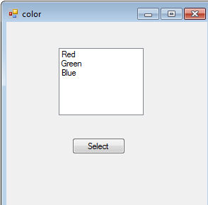

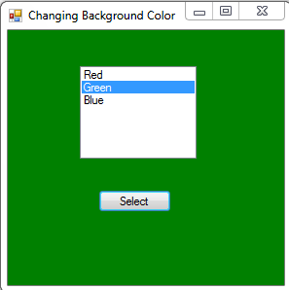

Public Class color

Private Sub Button1_Click(ByVal sender As System.Object, ByVal e As System.EventArgs) Handles Button1.Click

'Dim col As Integer = ListBox1.SelectedIndex

Dim it As String = ListBox1.SelectedItem

'Select Case col

' Case 0

' Me.BackColor = Drawing.Color.Red

' Case 1

' Me.BackColor = Drawing.Color.Green

' Case 2

' Me.BackColor = Drawing.Color.Blue

'End Select

Select Case it

Case "Red"

Me.BackColor = Drawing.Color.Red

Case "Green"

Me.BackColor = Drawing.Color.Green

Case "Blue"

Me.BackColor = Drawing.Color.Blue

End Select

Me.Text = "Changing Background Color"

End Sub

End Class